Lab 06 – Fullstack Web Development Report

Student Details
Name: Himanshu Kumar Enrollment: CS-23411144 Section: 3CSE-12

Repository Name: Lab-6
Repository Link: https: https://github.com/himanshukumarcs27-prog/lab06-node-fullstack-skeleton

Aim
To understand fullstack web development project setup including backend server creation, frontend initialization, and GitHub repository management.

Essential Commands Used
- Command Used: mkdir my-app && cd my-app
- Command Used: mkdir backend frontend
- Command Used: git init
- Command Used: npm init -y
- Command Used: npm install express cors dotenv
- Command Used: npm install -D nodemon
- Command Used: npm create vite@latest template react
- Command Used: npm install
- Command Used: npm run dev

Centralized Environment File
A centralized .env file is used to store database connection strings and sensitive configuration like PORT, DATABASE_URL, and SECRET_KEY.

Screenshot Evidence Section
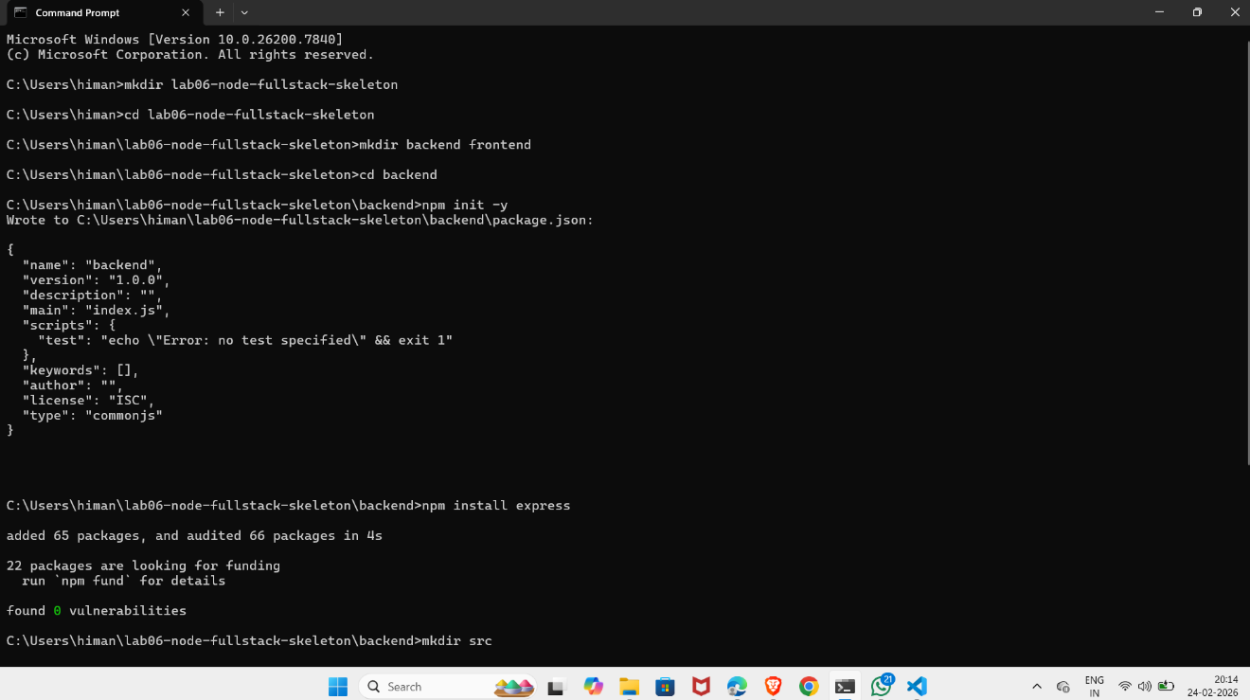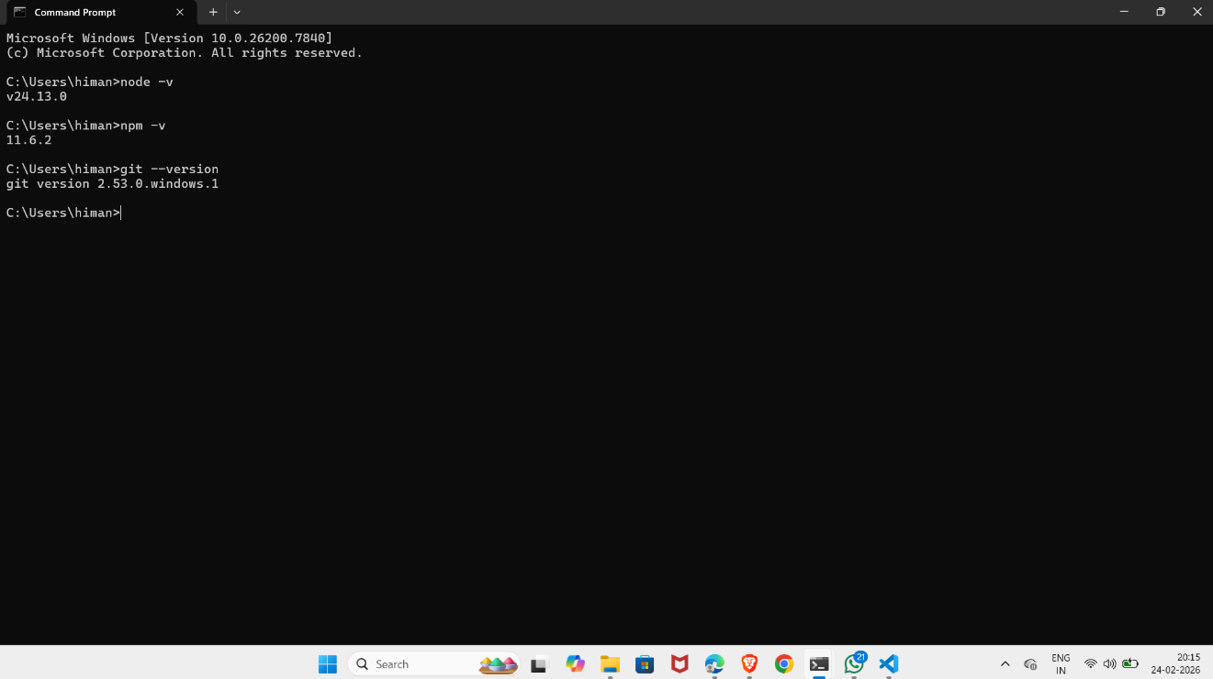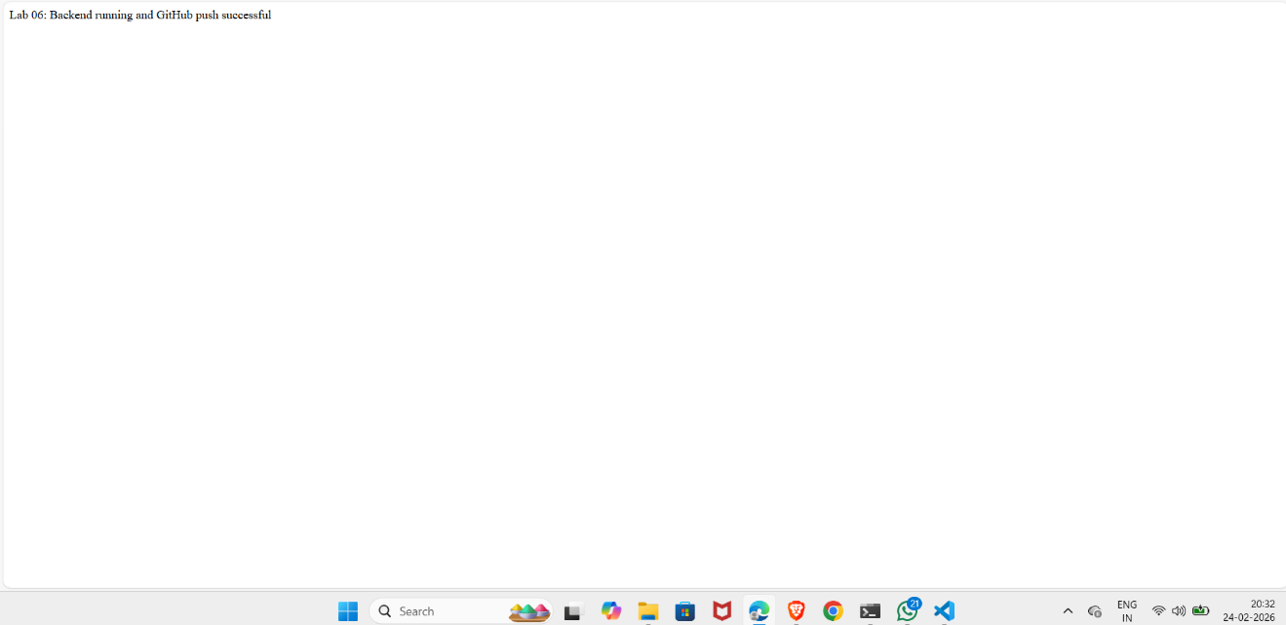

Conclusion
This laboratory exercise helped in understanding project setup, backend and frontend development, and version control using GitHub.

